Operating System

Assignment Simulation

A barrier is a tool for synchronizing the activity of a number of threads. When a thread reaches a barrier point, it cannot proceed until all other threads have reached this point as well. When the last thread reaches the barrier point, all threads are released and can resume concurrent execution.
Assume that the barrier is initialized to N —the number of threads that must wait at the barrier point:
init(N);
Each thread then performs some work until it reaches the barrier point:
/* do some work for awhile */
barrier point();
/* do some work for awhile */

Using synchronization tools like locks, semaphores and monitors, construct a barrier
that implements the following API :-

• int init(int n) —Initializes the barrier to the specified size.
• int barrier point(void) —Identifies the barrier point. All
threads are released from the barrier when the last thread reaches this point.

The return value of each function is used to identify error conditions. Each function will return 0 under normal operation and will return −1 if an error occurs.

Submitted by:- Submitted to:-

Student Name:-Shashikant Prasad Mam Nahida Nazir
Student ID:-11711844
Section No:- EE033
Roll No.:-58

Barriers

A barrier is a type of synchronization method. A barrier for a group of threads or processes in the source code means any thread/process must stop at this point and cannot proceed until all other threads/processes reach this barrier.

A barrier is a method to implement synchronization. Synchronization ensures that concurrently executing threads or processes do not execute specific portions of the program at the same time. When a barrier is inserted at a specific point in a program for a group of threads [processes], any thread [process] must stop at this point and cannot proceed until all other threads [processes] reach this barrier.

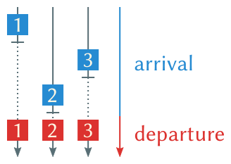

Algorithm:
1. initialize barrier_size and thread_count;
2. create threads
3. threads doing some work
4. threads waiting at the barrier.
5. barrier is released when last thread comes at the thread.
6. all threads complete thier task and exit.
7. exit.

Complexity:
O (n) complexity. “n” is no of thread_count.

C++ program for the question:-
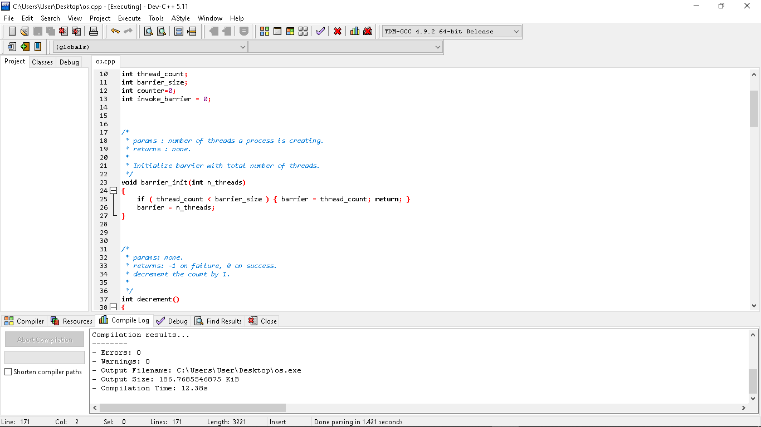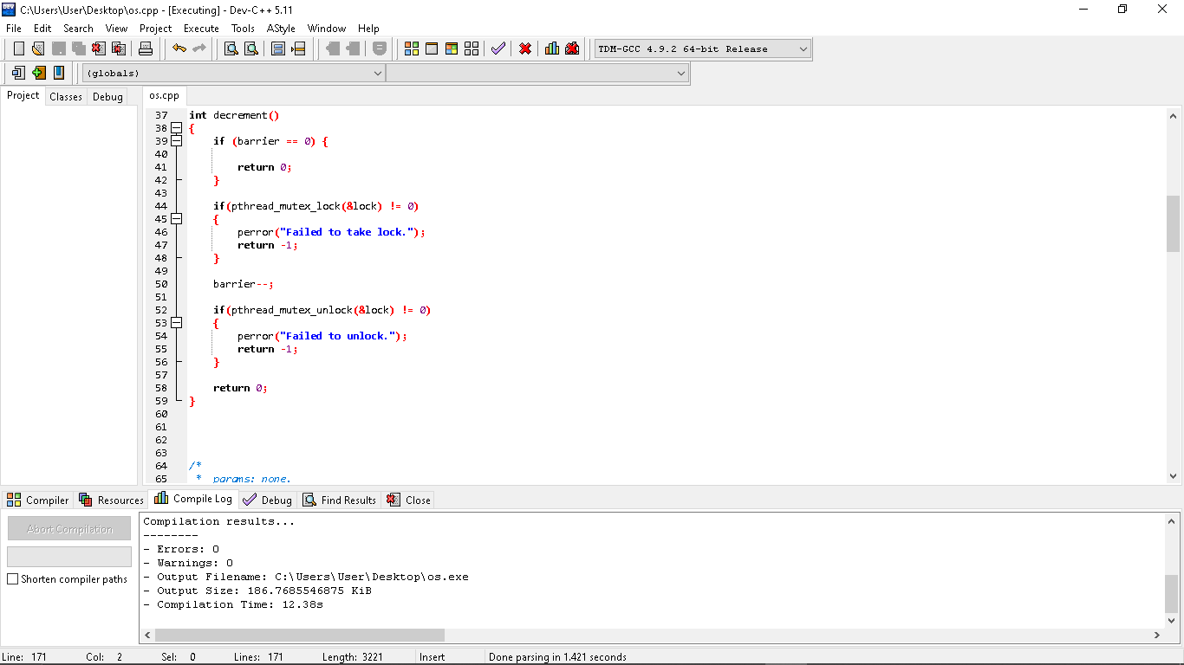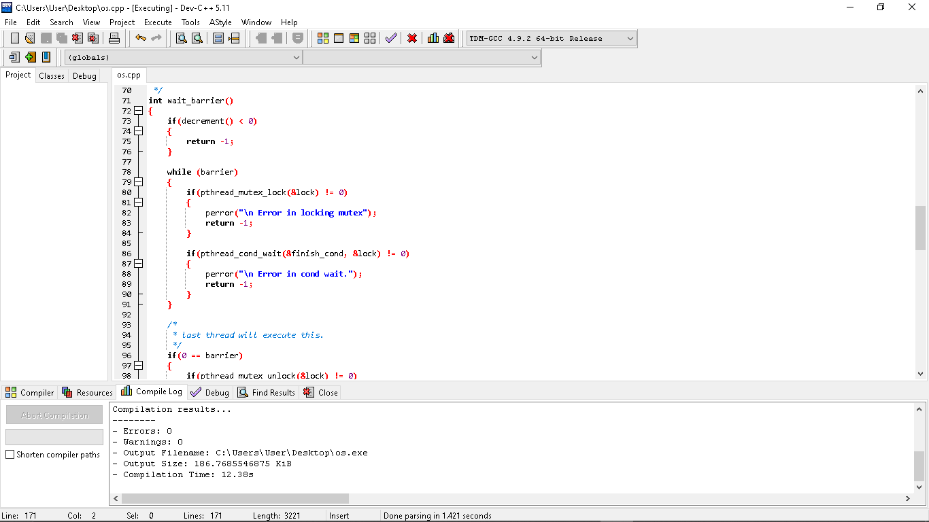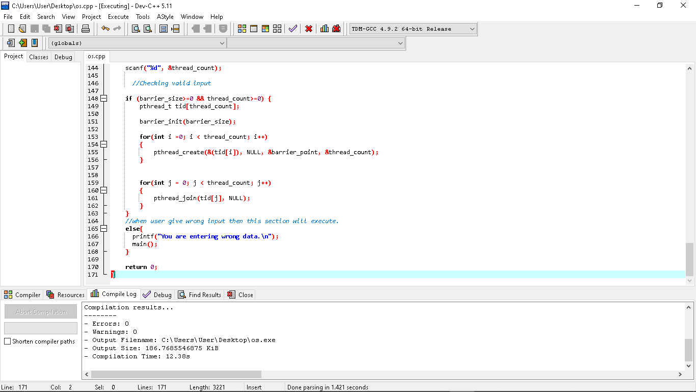Case 1:- When user enter invalid input like – Negative no.

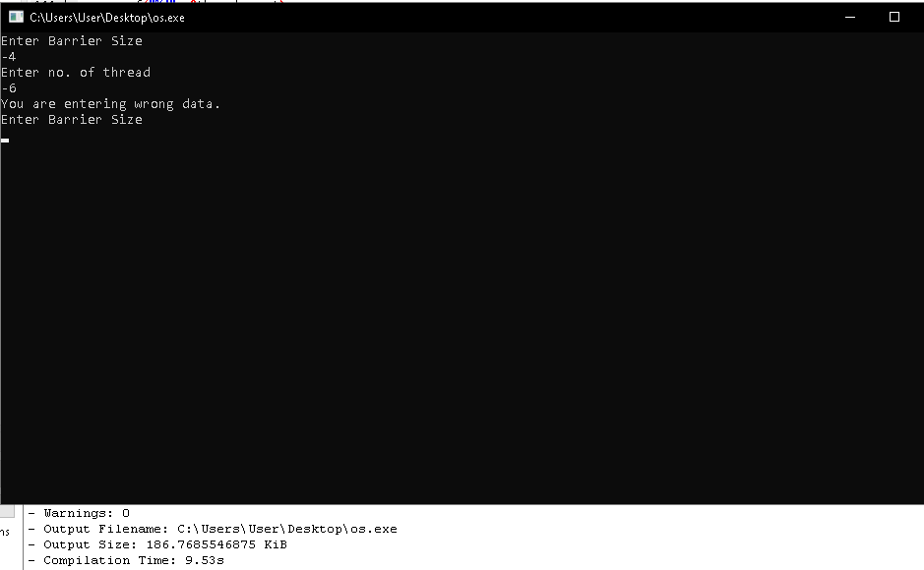

Case 2:- Number of thread equal to Size of barrier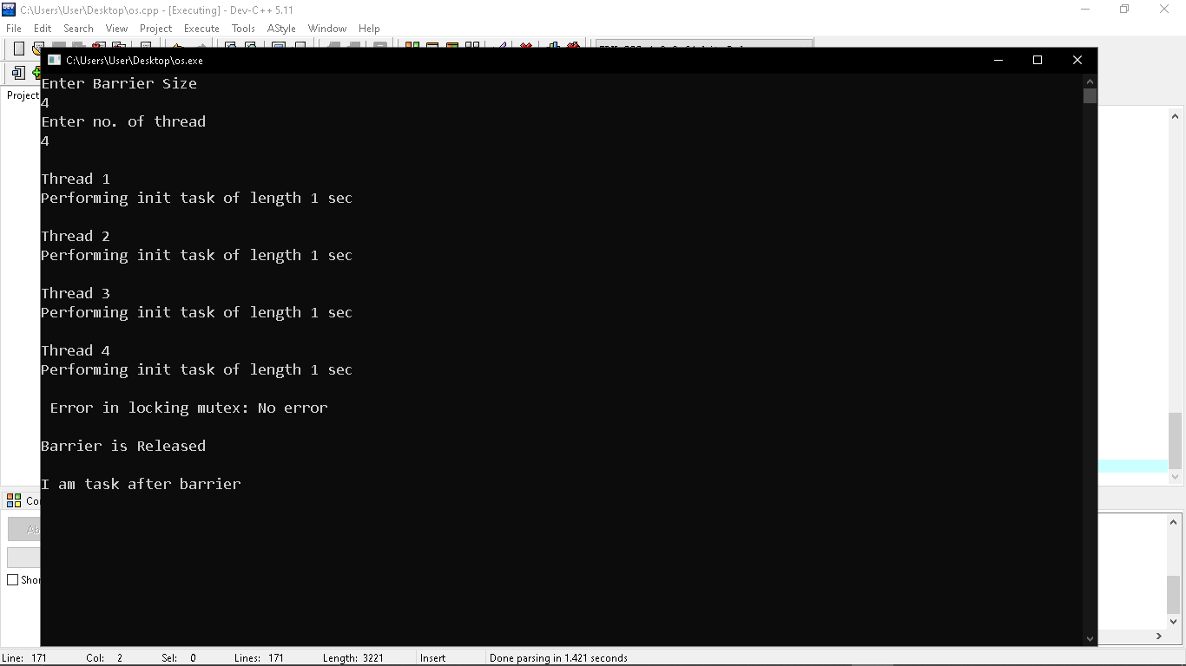

Case 3:-When number of thread is less than size of barrier:-
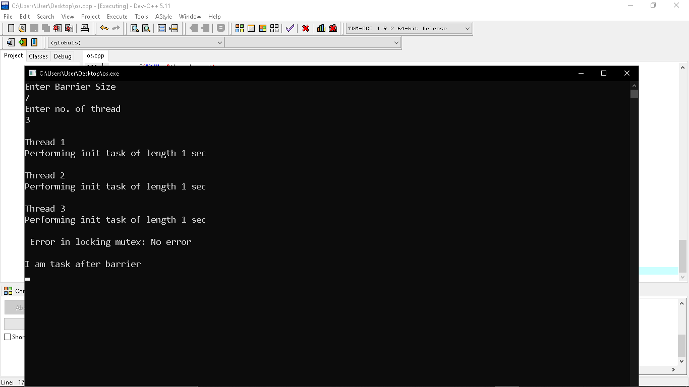

Case 4:-When no. of thread os greater than size of barrier.
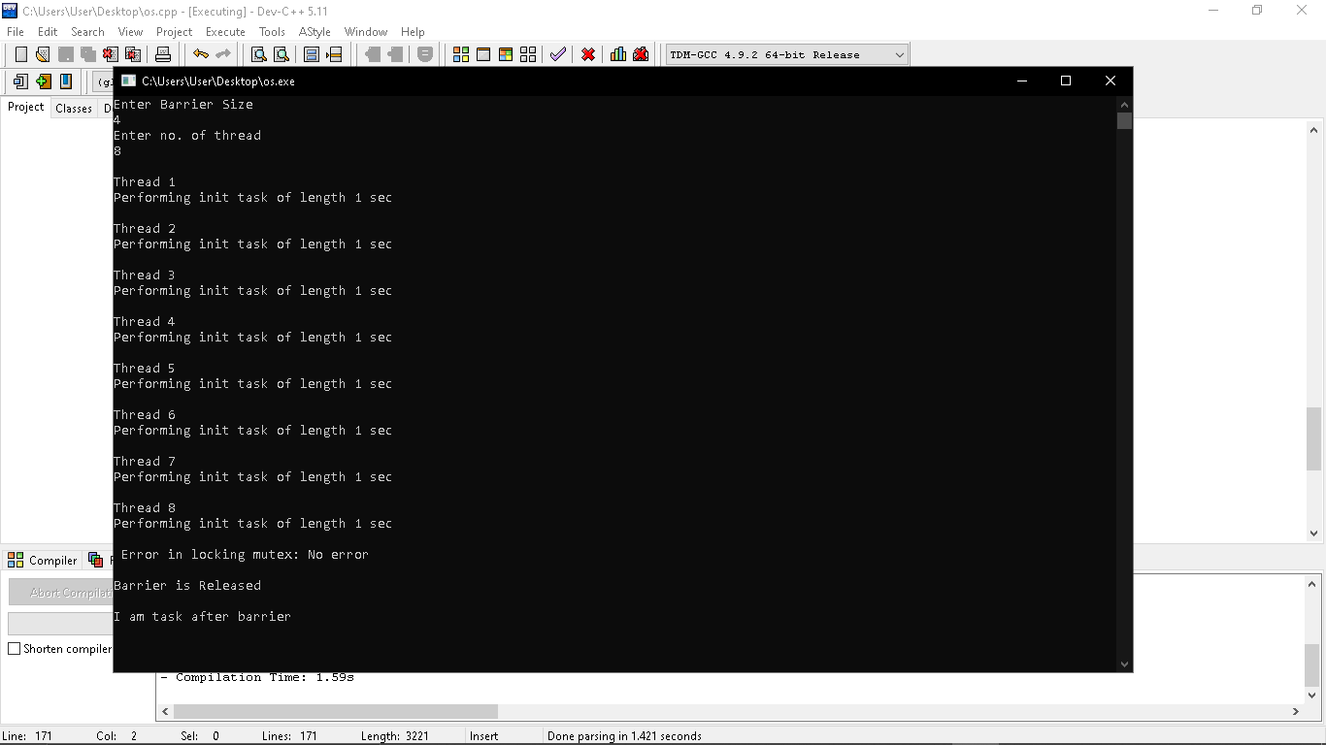
Case 5:-When size of barrier is equal to 0
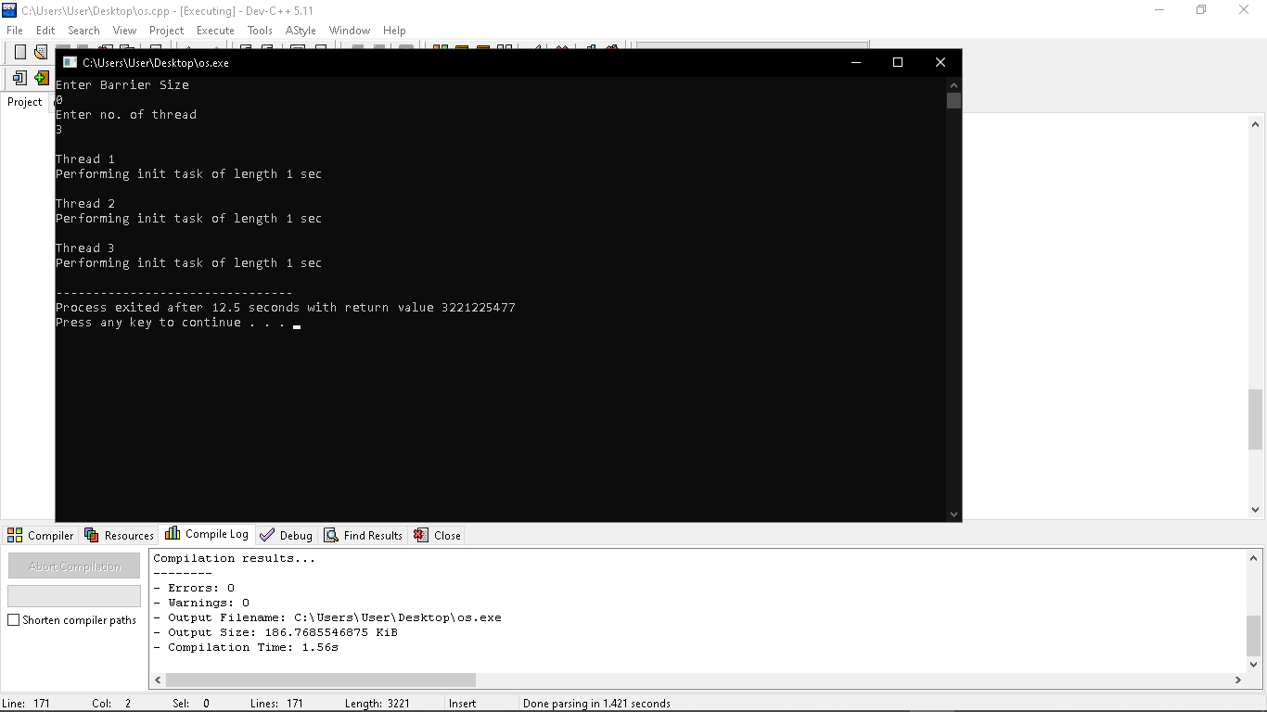

Case 6:-When thread is equal to 0
